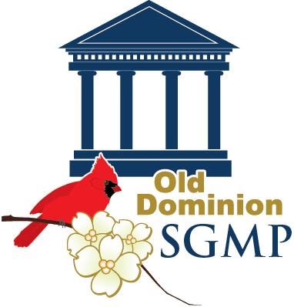
Old Dominion Chapter 2015 Education Conference
What Fuels You?
March 3 – 4, 2105
Embassy Suites Hampton & Hampton Convention Center

Tuesday, March 3
3:00 – 5:00 PM Board of Directors Meeting
Location: Rapture Board Room at the Embassy Suites
5:30 – 6:30 PM Reception hosted by The Embassy Suites
Location: Mercury Salon C
7:00 PM Dine Around - Group Dinner at Park Lane Restaurant followed by Dessert at Ethereal Cupcakes and Coffee Shop (each pays own/transportation will be provided)
Wednesday, March 4
7:00 AM Breakfast on your own in the hotel restaurant/atrium
8:00 AM - 8:30 AM Registration at the Convention Center
Location: Meeting Room 107 Foyer
8:30 AM – 9:30 AM Opening Session Keynote “Passion, Power, and Purpose: Renewal in a Demanding World” Speaker: Sonia Aranza, Aranza Communications
Location: Meeting Room 107
9:30 AM - 9:45 AM Break
9:45 AM – 10:45 AM Breakout Session 1 - “Who Said the Guest of Honor Sits on the Right”
Speaker: Chris Young, Executive Director of CIFAL Atlanta
Location: Meeting Room 108
9:45 AM – 10:45 AM Breakout Session 2 - “Protocol Training for Meeting Professionals”
Speaker: Kimberly Pope, The Pope Institute for Polish, Poise, & Etiquette, LLC
Location: Meeting Room 109
10:45 AM – 11:00 AM Break
11:00 AM - 12:00 PM General Session “Body Fuel: Eating and Exercising on Travel”
Speaker: Marcia Dadds, MS, RDN
12:00 PM – 12:30 PM “Office Yoga 101” with Charles Waddell, Yoga Instructor
12:30 PM – 1:30 PM Lunch
Location: Embassy Suites Hotel Ballroom
1:30 PM – 2:30 PM General Session “Service Recovery: Always Having to Say “I’m Sorry”
Speaker: Chris Young, Executive Director of CIFAL Atlanta
2:30 PM – 2:45 PM Break & “Wine Pull” Fundraiser Winners
2:45 PM – 3:45 PM General Session “Collaborative Leadership”
Speaker: James B. Oliver, Jr.
4:00 PM Closing Remarks

