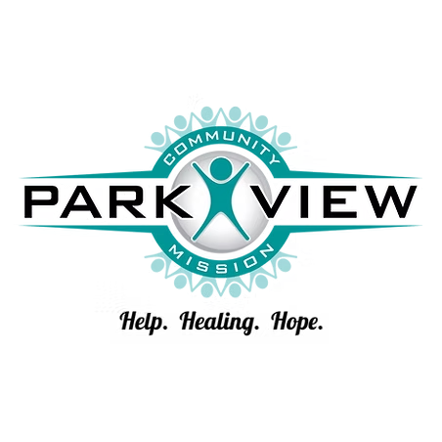
Park View Community Mission is our chosen charity for the 2025 Chapter Education Conference.
They serve individuals facing financial hardship, often due to crises like job loss or the loss of a spouse. Recognizing the cycle of poverty, they employ a holistic approach. Beyond providing immediate needs like food and clothing, they empower individuals through skill development and resource utilization, helping them build a better future. Guided by their motto – "Help. Healing. Hope." – Park View Community Mission aims to restore lives by fostering personal relationships and offering hope for a fulfilling life."

Below is a list of donation items needed, there will also be a Donation Jar for Cash Donations!
Donations are most needed in our Food for Families and Food for Thought programs. Needed items range from perishable and non-perishable food to clothing and personal hygiene items.

​FOOD:
Granola bars
Sandwich crackers
Peanut butter
Canned meat (tuna/chicken)
Hamburger Helper
Stuffing mix/rice
Macaroni & cheese
Canned fruit​

KITCHEN/HOUSEHOLD:
Towels and washcloths
General cleaners- like Mr. Clean or Pinesol
Dish liquid
Laundry Detergent
Blankets​
​
PERSONAL HYGIENE/BABY:
Body Wash
Shampoo
Toothpaste
Deodorant
Baby diapers - sizes 5 and 6 only
Feminine Products (Pads and Tampons)

